**Technical Validation:**

Over here they demonstrate some important parameters that could help a researcher in the selection as well as use of our data for the development and assessment of novel algorithms for Foetal ECG extraction and processing, PWD analysis and foetal cardiac physiology studies to assess the quality of the presented dataset.

As a result, the Foetal ECG signal was extracted from the raw data exploiting open-source algorithms and the procedure is described in the given figure of foetal ECG and heart rate extraction scheme.

**1) Foetal ECG extraction:**

1. The pre-processing stage consists of low-frequency baseline wander removal (below 0.05 Hz), high-frequency noise reduction (above 250 Hz), and power-line notch filtering (whenever required).
2. The maternal R-peaks are then detected from one of the reference thoracic channels. These peaks are used in a so-called deflation algorithm based on periodic component analysis to remove maternal ECG components.
3. In order to construct the auxiliary mECG, a reference beat is needed. This reference beat can be chosen arbitrarily by visual inspection or through an automatic selection. For an automatic procedure, the mECG reference beat is calculated by robust weighted averaging (RWA) [34], using the detected maternal R-peaks.
4. The data channels augmented with the auxiliary mECG can now be used in the GEVD/OGEVD scheme detailed in Section 3.1. For implementing OGEVD, the online form of matrix pair updates are used. The 1 In this method, the sliding window length is selected equal to the expected maternal R-peak period. For online applications, the window length can be updated adaptively based on the average of the maternal heart rate, over a long window (e.g. one minute long). performance of linear decomposition using GEVD/OGEVD highly depends on the efficient use of prior information regarding the signal and noise subspaces, gathered in the matrix pair
5. The R-peaks of the foetus were next detected from the fECG channel, using a matched filter with predefined templates. The resulting foetal R-peaks were eventually used for extracting the average fECG morphology.
6. Depending on the signal quality, the fetal ECG might be directly detectable from one or more of the residual channels; or one might require an additional stage for extracting the fetal ECG from the background noise.

**2)Dataset quality assessment**

The capability to extract the foetal QRS complexes by exploiting the PWD as a reference signal to check the actual occurrence of a ventricular activation in the foetal heart was analysed to provide some quantitative data to support the quality of the dataset.

Clinical information about mothers which includes mothers age , height, weight, prev pregenency, and risk of pregnancy.

This is the only option to check the actual effectiveness of a fECG extraction algorithm in early pregnancy, which is not available in any of the available datasets for non-invasive fECG analysis and processing.

The quantitative parameters considered for this assessment were: Accuracy (Acc), Sensitivity (Se), and Positive predictive value (PPV), computed as:

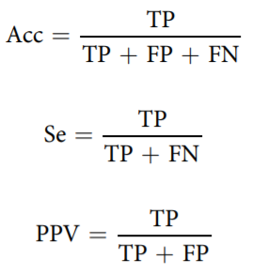

where TP is the number of true positive detections, FP is the number of false positive detections, and FN is the number of false negative detections. Since the detected fECG R-peaks are compared with the V-peaks in the PWD, accuracy does not account for the true negatives and it is identical with the critical success index in the context of machine learning, which accounts for the total hits divided by the number of hits plus false alarms and misses.

The fECG and acceptable QRS detection were extractable from 95.5% of the data segments i.e. the percentage of the data segments without considerable noise contamination, by using the semi-supervised procedure described above.

Table 5 lists the evaluation results of the R-peak detection. The median Acc, Se and PPV values were 0.79, 0.97 and 0.81, respectively.

**Result:**

This dataset is particularly important for scientists working on foetal ECG extraction from non-invasive recordings because it is the first multimodal dataset in early pregnancy, including non-invasive electrophysiological, maternal respiration.

* The quantitative parameters considered for this assessment were: Accuracy (Acc), Sensitivity (Se), and Positive predictive value (PPV).

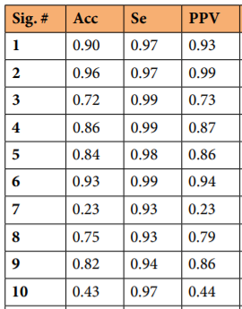

* The median Acc, Se and PPV values were 0.79, 0.97 and 0.81, respectively.
* Then, instantaneous fHR from the fECG and PWD were evaluated and compared.
* The comparison was mainly qualitative and affected by both the different time resolutions of the two signals and limited accuracy in identifying fiducial points on the PWD signals.
* The average value for each trace was derived from the instantaneous values.